OCTOBER 24, 2016
3RD ANNUAL SPAGHETTI DINNER FUNDRAISER
To Benefit The Unionville Tavern Preservation Society
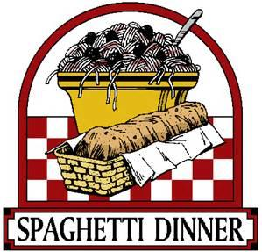
Join us at the Wagon Wheel Restaurant & Bar in Madison, 5-8pm
TICKETS $10/Each

CHINESE AUCTION BASKETS NEEDED!
We are asking for assistance from the community for this event in the form of sponsorship and for the Chinese Action. This event has sold out in years past. For the Chinese raffle, themed baskets would be most appreciated and could highlight your business or get together with friends and together make a wonderful basket for the auction.
Any donation is appreciated.
Please contact Michelle Gerred at UnionvilleTavernEvents@gmail.com, subject: SPAGHETTI DINNER or (440)487-7795 if you would like to discuss a donation. We thank you so much!
Together We Can “Save the Tavern!”

